FLDOE Assessments: | Gibbs Assessment Dates: | FLDOE Test windows:
FAST Grade 10 ELA Reading Retakes | 1st Window: 9/9  2nd Window: 12/2 moved to 12/9  3rd Window: 5/12  4th Window: 7/14 | 1st Window: 9/9 – 10/4  2nd Window: 12/2 – 12/20  3rd Window: 5/1 – 5/30  4th Window: 7/14 – 7/25
BEST Algebra 1 & Geometry Retakes | 1st Window: 9/10  2nd Window: 12/3 moved to 12/10  3rd Window: 5/13  4th Window: 7/15 | 1st Window: 9/9 – 10/4  2nd Window: 12/2 – 12/20  3rd Window: 5/1 – 5/30  4th Window: 7/14 – 7/25
FAST ELA Reading | PM1: ELA Class period  PM2: ELA Class Period  PM3: 5/1(9th grade) 5/2(10th grade) | PM1: 9/3 – 9/27  PM2: 12/2 – 12/20 (Make-Ups thru 24th) PM3: 5/1 – 5/9 (Make-Ups thru 29th)
BEST Writing | 9th grade: 4/4  10th grade: 4/3 | 3/31 – 4/11
BEST Algebra I EOC | Cycle 1: Algebra Class Period  Cycle 2: Midterm exam schedule  Cycle 3: Algebra Class Period EOC: 5/5 | Cycle 1 Window: 9/30 – 10/11  Cycle 2(Midterm) Window: 12/17 – 12/20  Cycle 3 Window: 2/24 – 3/14  BEST Algebra EOC Window: 5/1 – 5/30
BEST Geometry EOC | Cycle 1: Geometry Class Period  Cycle 2: Midterm exam schedule  Cycle 3: Geometry Class Period EOC: 5/6 | Cycle 1 Window: 9/30 – 10/11  Cycle 2(Midterm) Window: 12/17 – 12/20  Cycle 3 Window: 2/24 – 3/14  BEST Geometry EOC Window: 5/1 – 5/30
FSA US HISTORY EOC | Cycle 1: US History Class Period  Cycle 2: Midterm exam schedule  Cycle 3: US History Class Period EOC: 5/7 | Cycle 1 Window: 9/30 – 10/11  Cycle 2(Midterm) Window: 12/17 – 12/20  Cycle 3 Window: 2/24 – 3/14  US History EOC Window: 5/1 – 5/30
FSA BIOLOGY EOC | Cycle 1: Biology Class Period  Cycle 2: Midterm exam schedule  Cycle 3: Biology Class Period EOC: 5/8 | Cycle 1 Window: 9/30 – 10/11  Cycle 2(Midterm) Window: 12/17 – 12/20  Cycle 3 Window: 2/24 – 3/14  Biology EOC Window: 5/1 – 5/30
*Civic Literacy  Assessment (grades 9 & 12) | Semester 1: Midterm exam schedule  Semester 2: 5/9 | Semester 1 Window: 11/4 – 12/20  Semester 2 Window: 3/31 – 5/30
ACCESS for EL (ELL) | 3/3 – 3/13 | Window: 1/20 – 3/14
FSAA Performance Tasks (ACCESS ESE) | ESE Team | 10th grade ELA & Algebra 1 Make-Ups: 9/23 – 10/11  9th & 10th grade Window:  ELA/Writing, Algebra, Biology, Geometry & US History:  3/10 – 4/25
PCS Assessments: | Gibbs Assessment Windows: | PCS Assessment Windows:
PCS Visual and  Performing Arts common  assessments | 1st Semester: 12/5 – 12/13 Make-ups thru 12/20  2nd Semester: 5/13 – 5/16  Make-ups thru 5/29 | 1st Semester: 12/5 – 12/13 Make-ups through 12/20  2nd Semester: 5/13 – 5/16 Make-ups through 5/29
PCS World  Languages performance tasks | 1st Semester: Midterm Term Exam period  2nd Semester: 4/14 – 4/18 (make-ups thru 5/9) | 1st Semester: 12/17 – 12/20  2nd Semester: 4/14 - 4/18  Make-ups through 5/9
S1 and S2 exams and PCS common assessments (for selected courses) | 1st Semester:  2nd Semester | 1st Semester: 12/17–12/20  2nd Semester: 5/23-5/29
National Assessments: | Gibbs Assessment Windows:
ACT In School NCR | GHS 1st Semester Test Date: 10/22 moved to 11/5 (Reading) & 10/24 moved to 11/6  (Math) 11th & 12th Grade concordant only  1st Semester Window: 10/21 – 10/25  GHS 2nd Semester Test Date: 4/9 (Reading) & 4/10 (Math) 11th & 12th Grade concordant only  2nd Semester Window: 4/8 – 4/11
ACT (Saturdays) | 1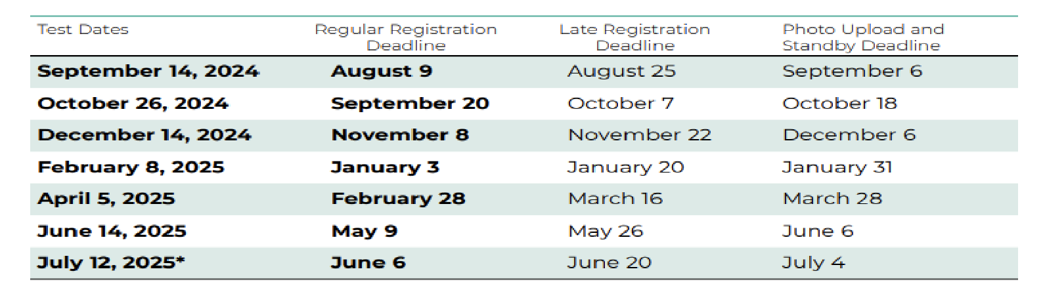
SAT In School & NCR | GHS 1st Semester Test Date: 10/9 moved to 10/23  1st Semester Window: 10/1 – 10/31 (12TH GRADE ONLY)  GHS 2nd Semester Test Date: 3/5 (11th grade) and 3/6 (12th grade) 2nd Semester Window: 3/3 – 4/20
SAT (Saturdays) | 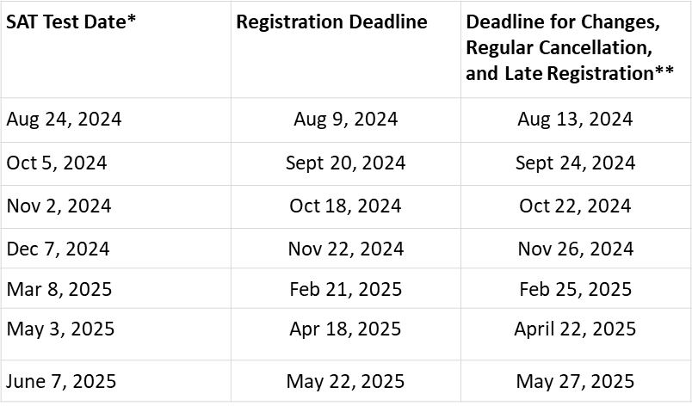
PSAT | 1st Semester Window: 10/1 – 10/31  Grade 11: 10/15 moved to 10/22 (Lastname A – L) 10/16 moved to 10/24 (Lastname M-Z)  Grade 10: 10/17 moved to 10/30 (Lastname A – L) 10/18 moved to 10/31 (Lastname M-Z)  Grade 9: 10/28 (Lastname A – L) 10/29 (Lastname M-Z) NO DATE CHANGE NEEDED
ASVAB | TBD
Advanced Placement | SEE BELOW
AICE Exams | AICE General Paper: Day 1 - 4/25 AM and Day 2 - 4/29 AM AICE Marine Science: Day 1 - 4/25 PM and Day 2 - 4/29 PM
Classic Learning  Test (CLT)  Concordancy Only | 8/15, 9/18, 10/16, 11/7, 2/20, 4/10

AP Exam Schedule
Week 1 Schedule
 | 8 a.m. Local Time | 12 p.m. Local Time
Monday,  May 5, 2025 | Biology | European History Microeconomics
Tuesday,  May 6, 2025 | Chemistry | United States Government and Politics
Wednesday, May 7, 2025 | English Literature and Composition | Computer Science A
Thursday, May 8, 2025 | Statistics | World History: Modern
Friday,  May 9, 2025 | United States History
AP Art and Design: Friday, May 9, 2025 (8 p.m. ET), is the deadline for AP Art and Design students to submit their three portfolio components as final in the AP Digital Portfolio.
Week 2 Schedule
 | 8 a.m. Local Time | 12 p.m. Local Time
Monday,  May 12, 2025 | Calculus AB Calculus BC | Music Theory Seminar
Tuesday,  May 13, 2025 | Precalculus | Environmental Science
Wednesday, May 14, 2025 | English Language and Composition
Thursday,  May 15, 2025 | Art History  Spanish Language and Culture | Computer Science Principles
Friday,  May 16, 2025 |  | Psychology
Start Times
Exams have local start times and can begin up to one hour after the official start time. During the regularly scheduled exam administration, exams can begin between:
- 8 and 9 a.m. local time for morning exams.
- 12 and 1 p.m. local time for afternoon exams.
Exams with Digital Portfolios
- AP Seminar and AP Research students: April 30, 2025 (11:59 p.m. ET), is the deadline to submit performance tasks as final and for your presentations to be scored by your AP Seminar or AP Research teacher.
- AP Computer Science Principles students: April 30, 2025 (11:59 p.m. ET), is the deadline to submit your Create performance task as final.
- AP Art and Design students: May 9, 2025 (8 p.m. ET), is the deadline to submit your 3 portfolio components as final in the AP Digital Portfolio.

